Devices Connection 2
GigaEthernet 0/0 Configuration 3
GigaEthernet 0/1 Configuration 4
All Connections Green 5
GigaEthernet 0/0 & GigaEthernet 0/1 Configurations noted in workspace 6
PC0 Default Gateway Configuration 7
PC0 IP Address & Subnet Mask Configuration 8
PC1 Default Gateway Configuration 9
PC1 IP Address & Subnet Mask Configuration 10
PC2 Default Gateway Configuration 11
PC2 IP Address & Subnet Mask Configuration 12
PC3 Default Gateway Configuration 13
PC3 IP Address & Subnet Mask Configuration 14
All Configuration noted in workspace 15
Pinging PC1 from PC3 16
Pinging PC2 from PC3 17
Entering first set of commands in Router CLI 18
Pinging PC1 from PC0 19
Pinging PC2 from PC0 20
Pinging PC0 from PC2 21
Pinging PC1 from PC2 22
Entering second set of commands in Router CLI 23
Running Pings in PC0 again 24
Running Pings in PC2 again 25

Devices Connection
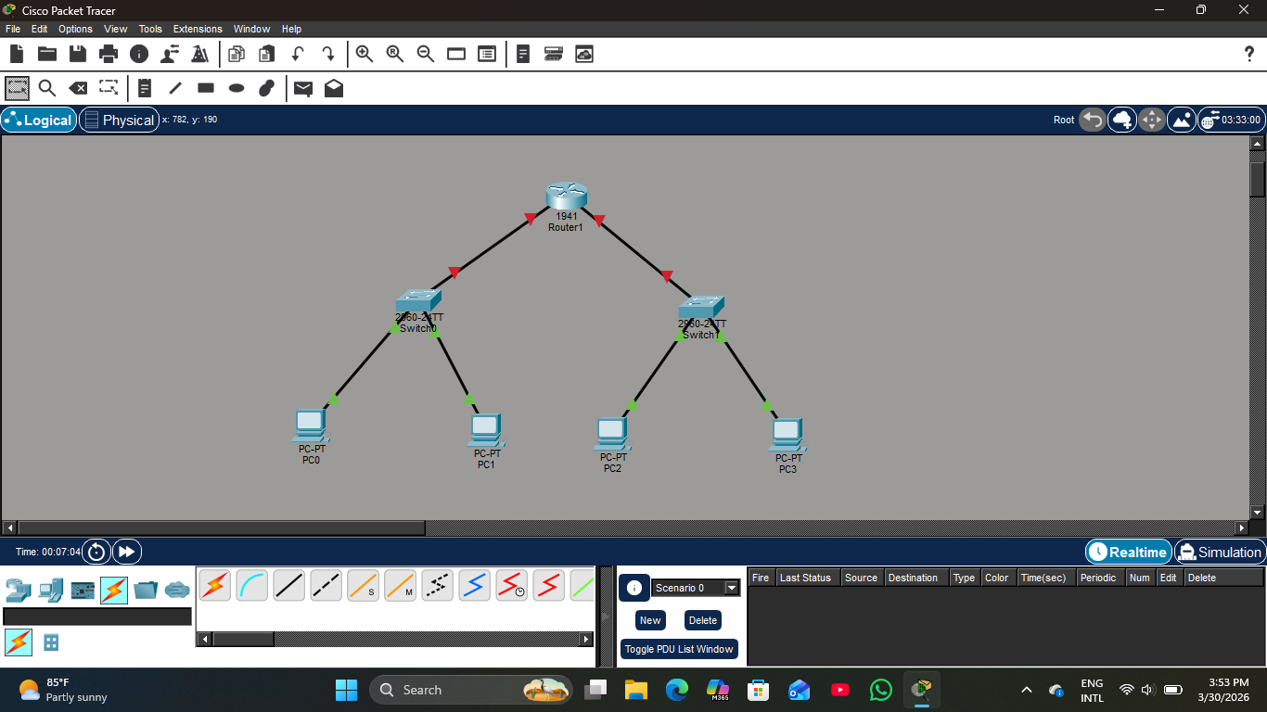

GigaEthernet 0/0 Configuration
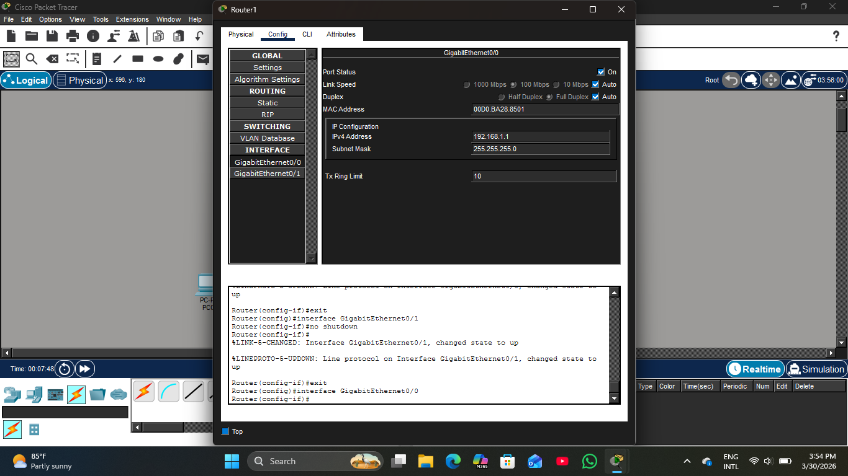

GigaEthernet 0/1 Configuration
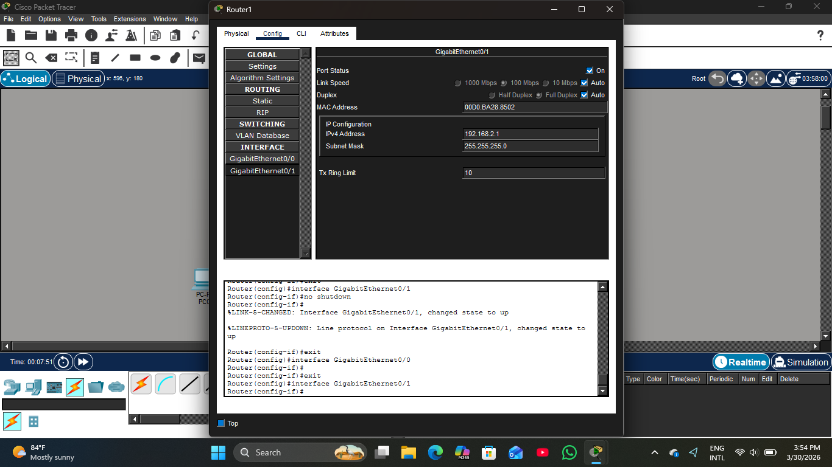

All Connections Green
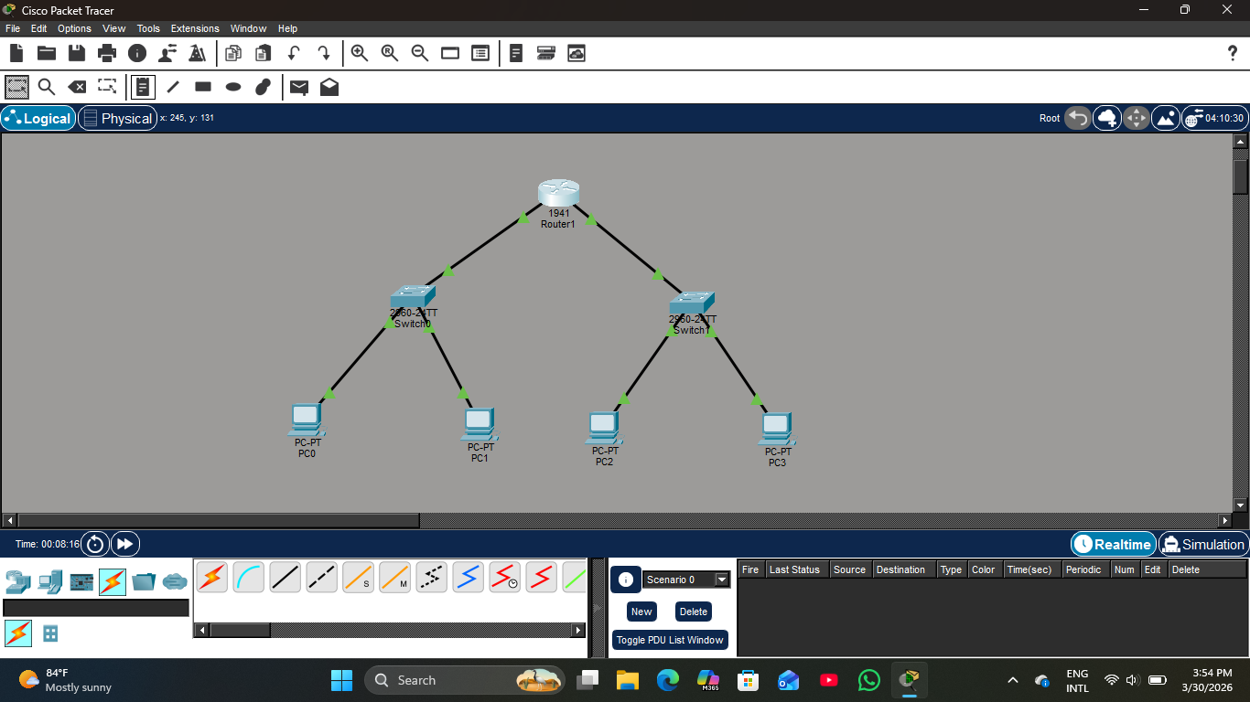

GigaEthernet 0/0 & GigaEthernet 0/1 Configurations noted in workspace

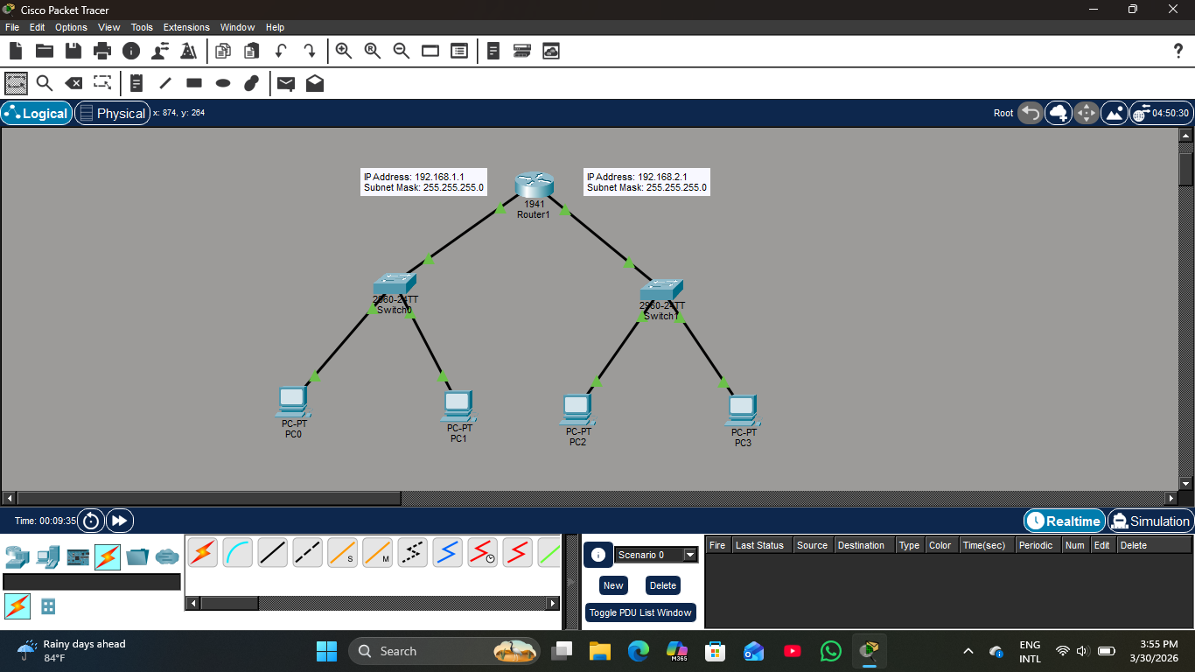

PC0 Default Gateway Configuration
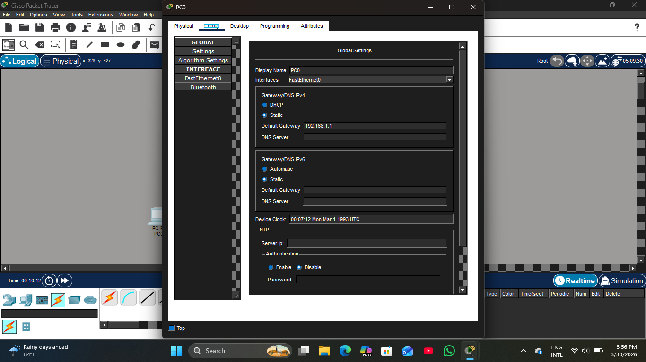

PC0 IP Address & Subnet Mask Configuration
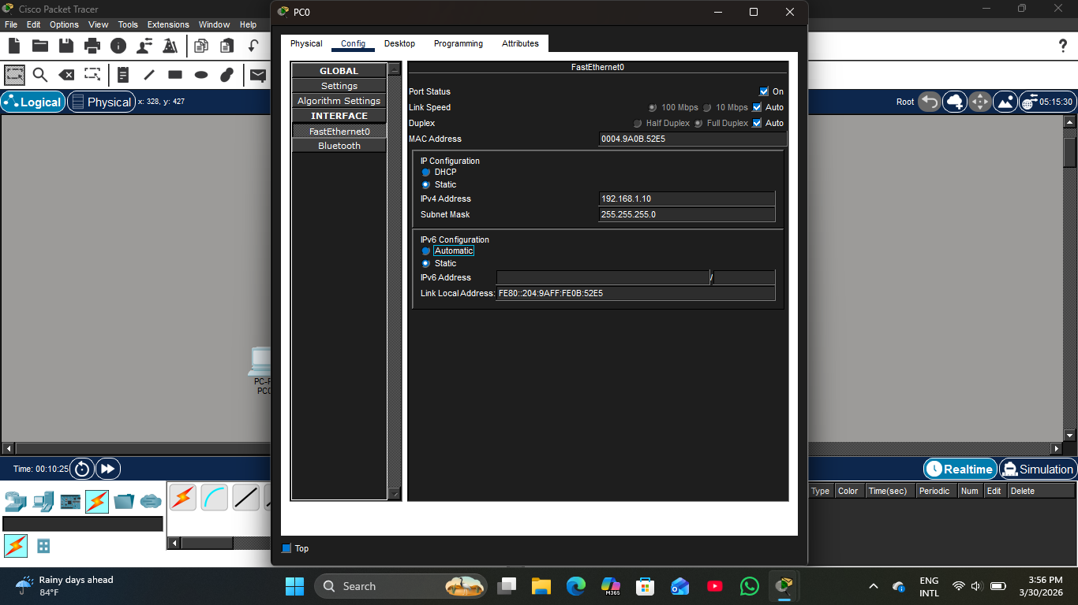

PC1 Default Gateway Configuration
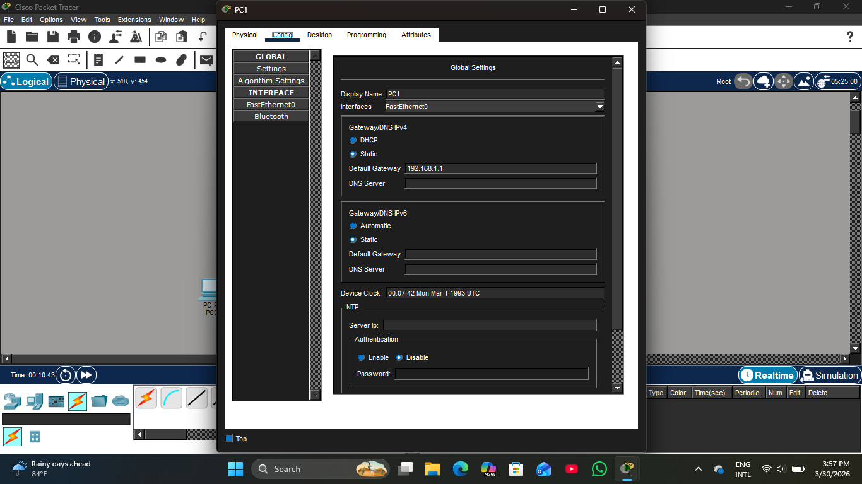

PC1 IP Address & Subnet Mask Configuration
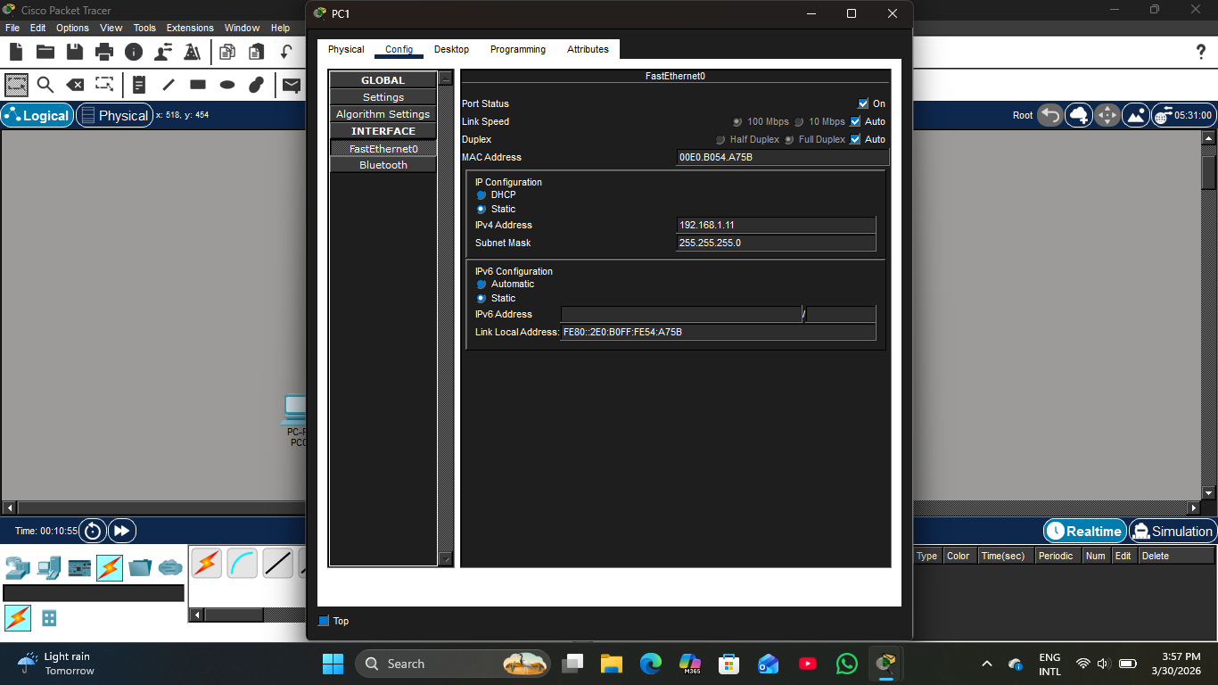

PC2 Default Gateway Configuration
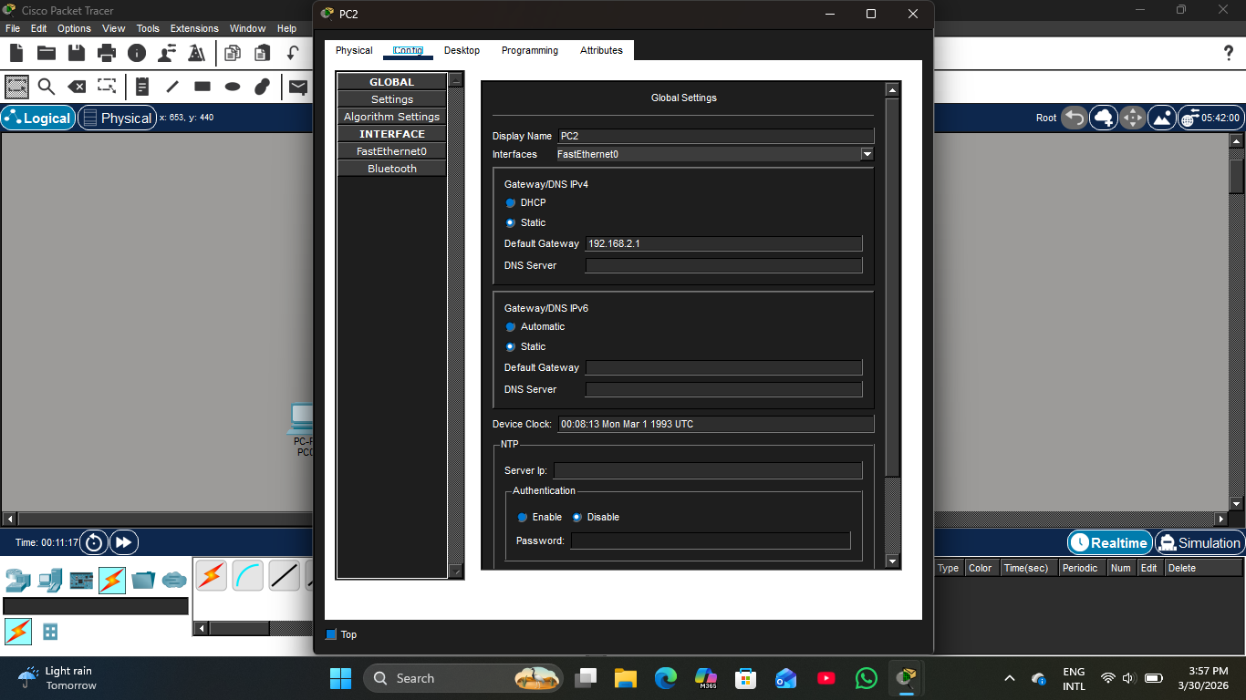

PC2 IP Address & Subnet Mask Configuration
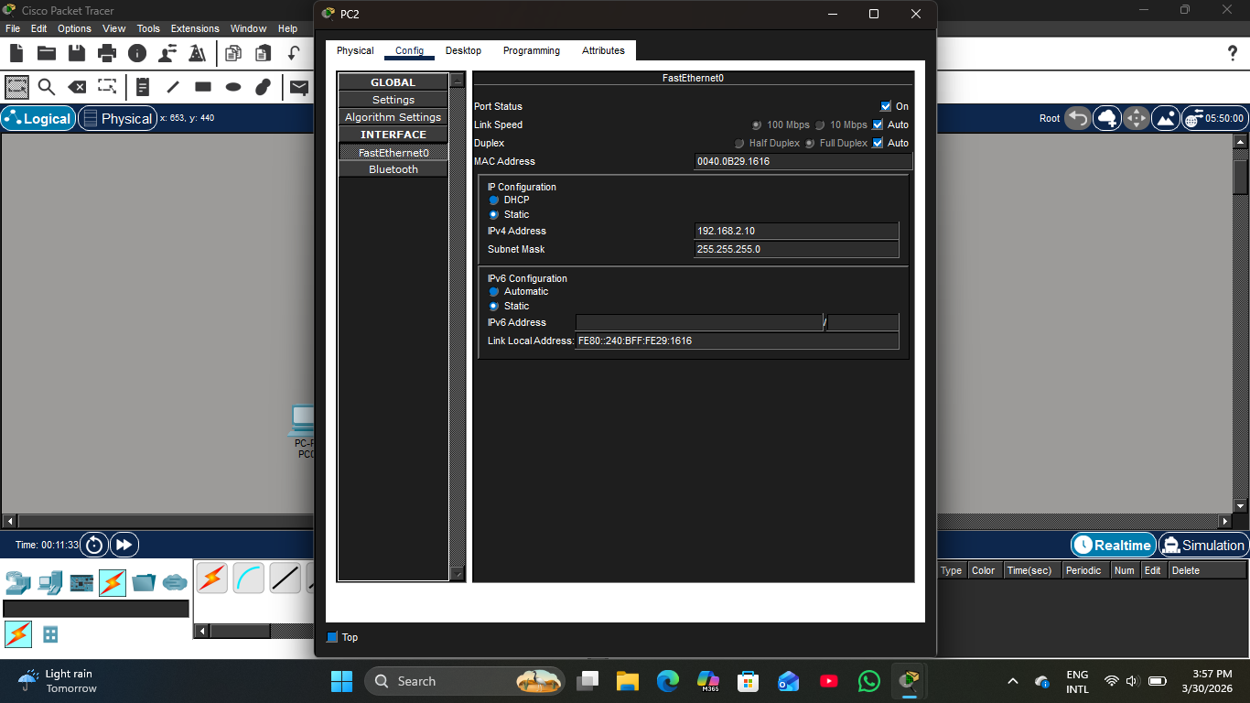

PC3 Default Gateway Configuration
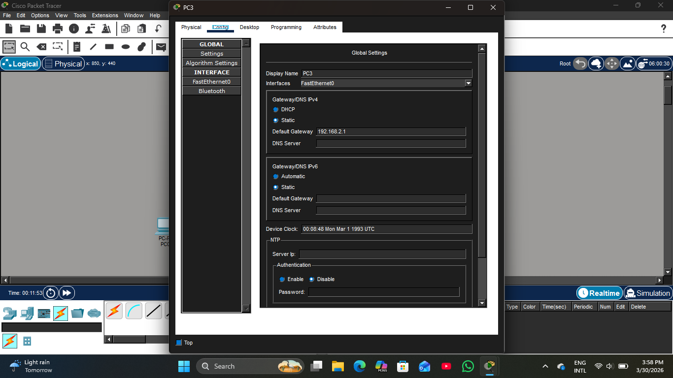

PC3 IP Address & Subnet Mask Configuration
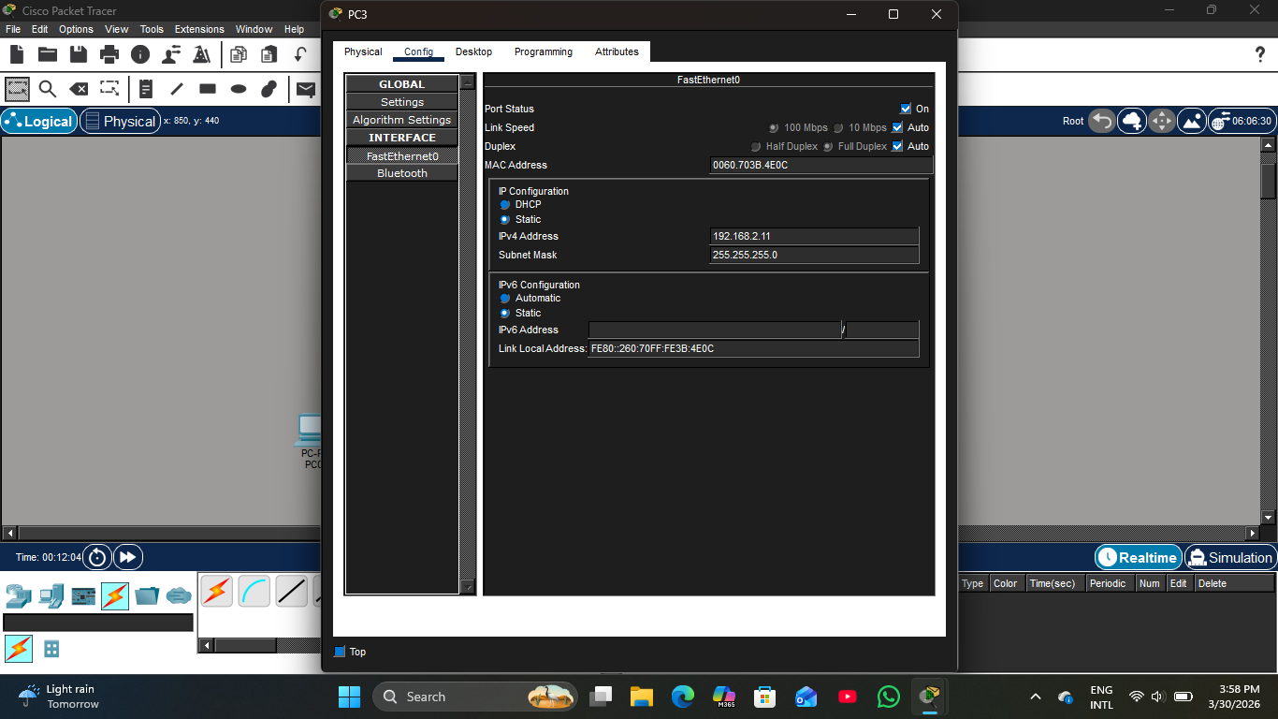

All Configuration noted in workspace
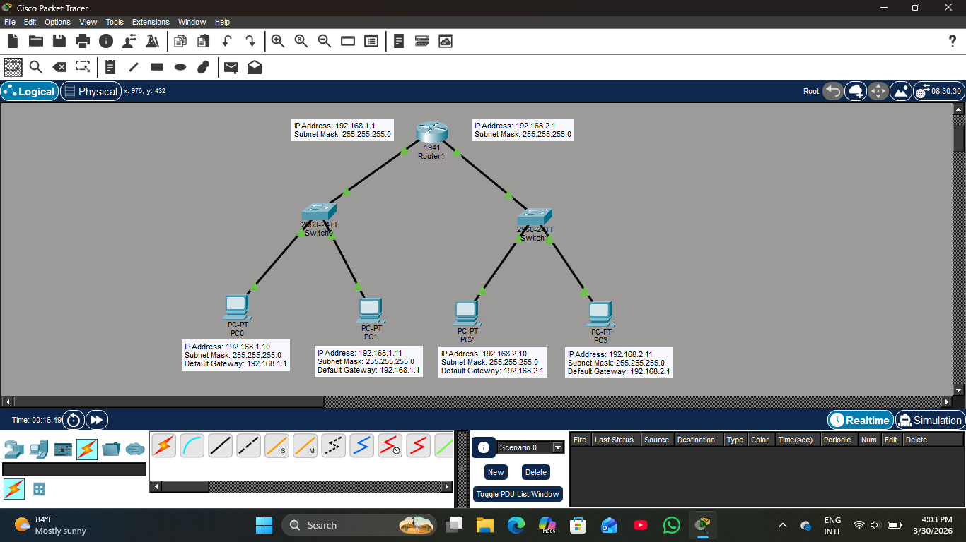

Pinging PC1 from PC3
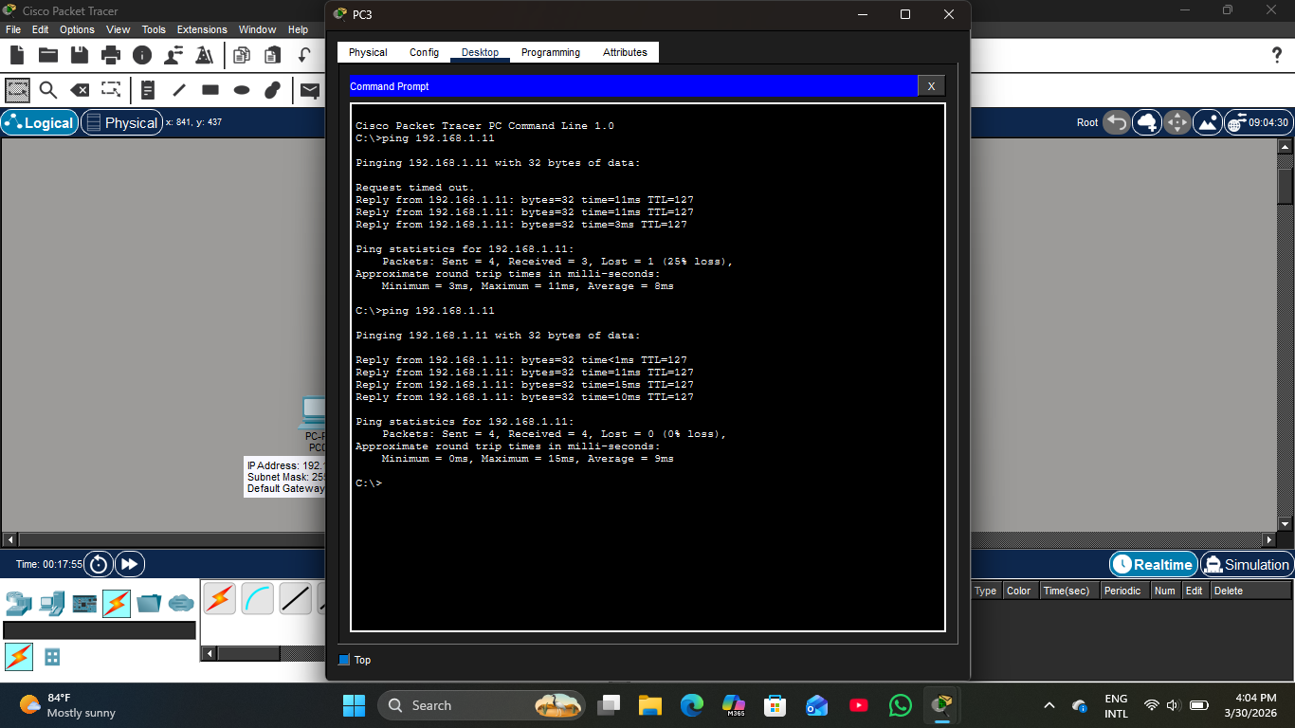

Pinging PC2 from PC3
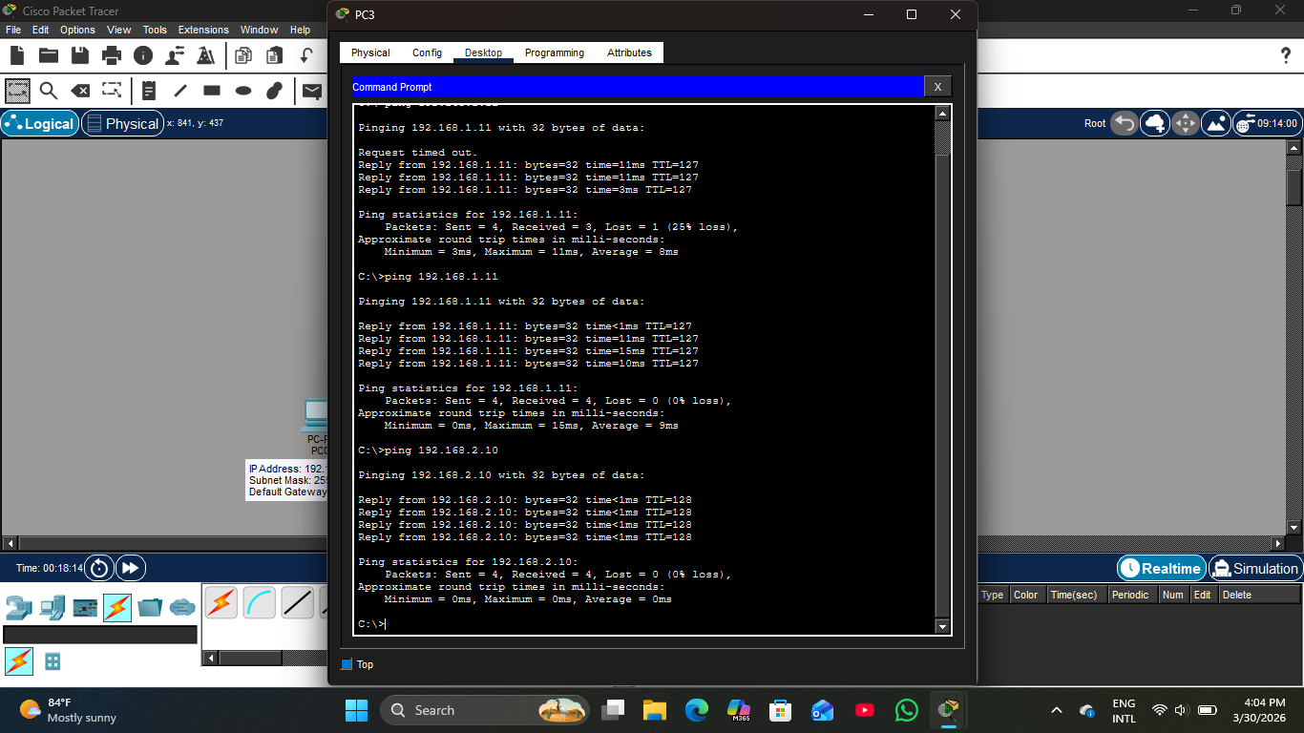

Entering first set of commands in Router CLI
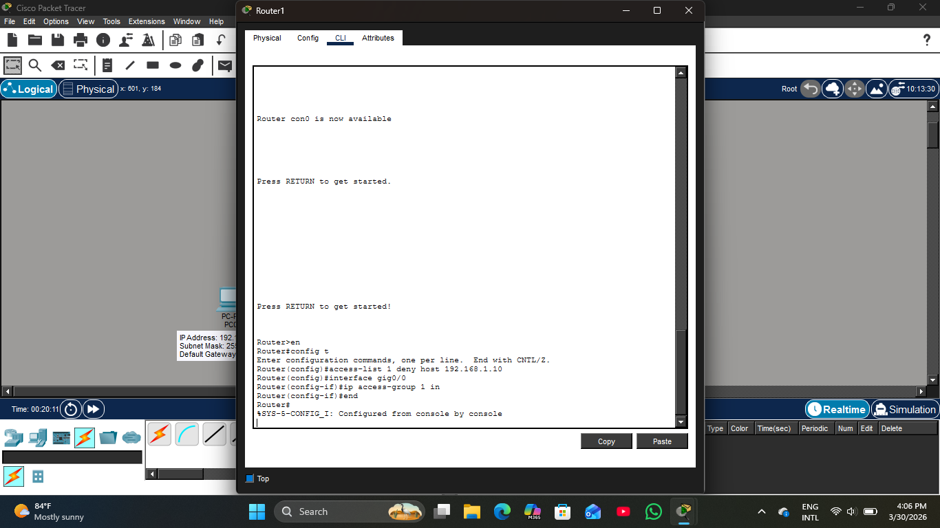

Pinging PC1 from PC0
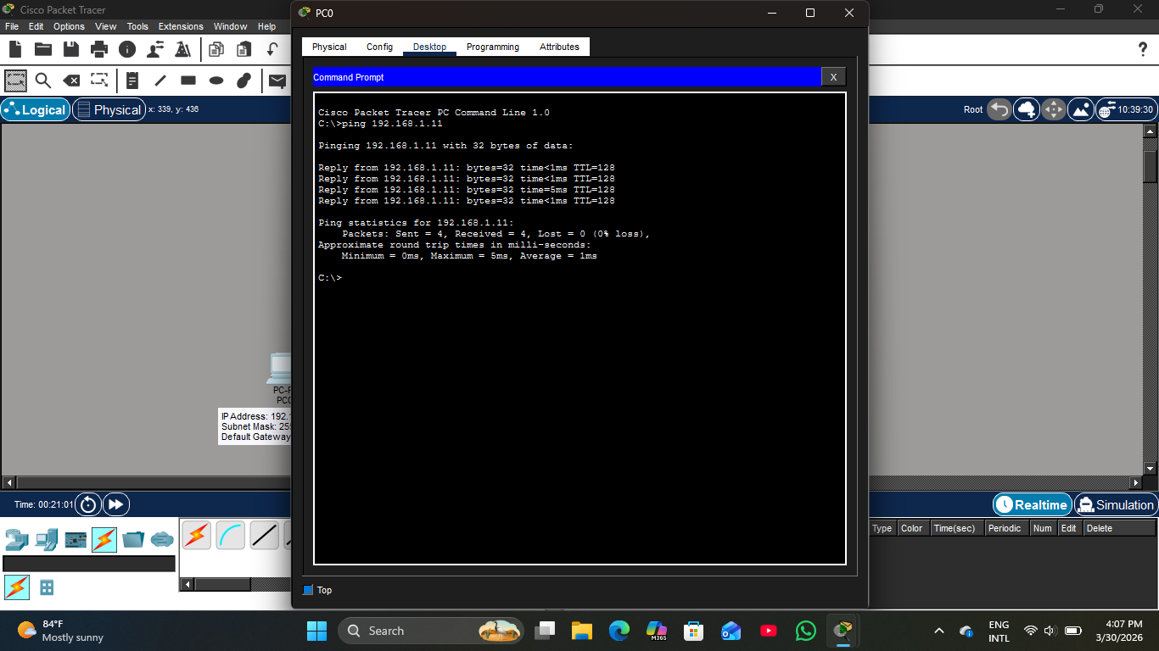

Pinging PC2 from PC0
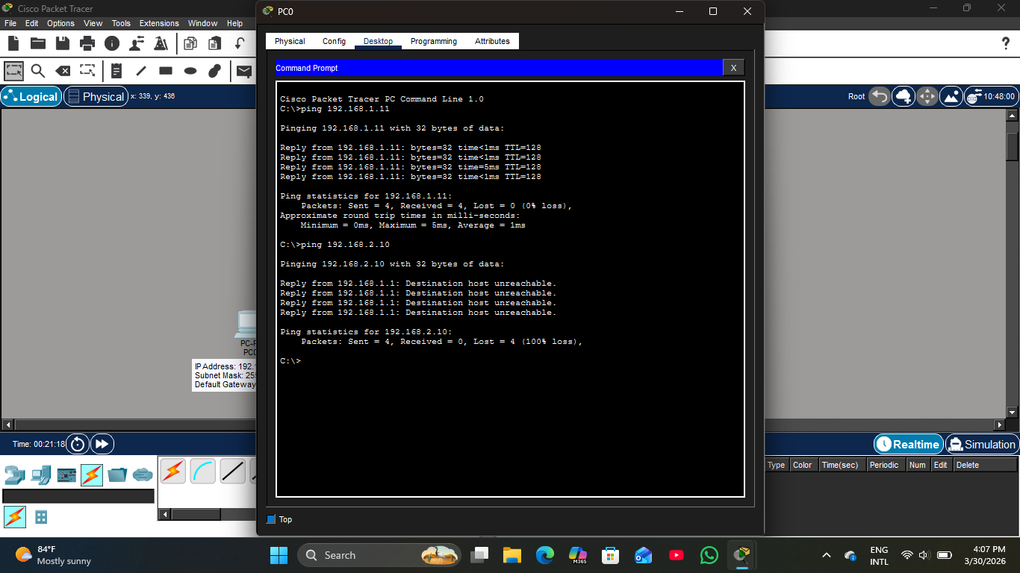

Pinging PC0 from PC2
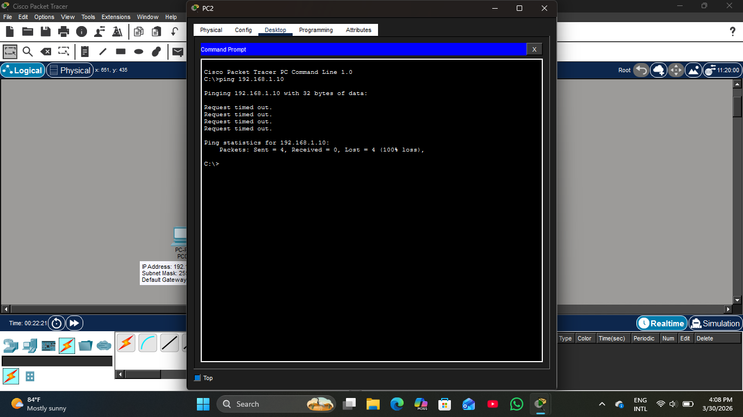

Pinging PC1 from PC2
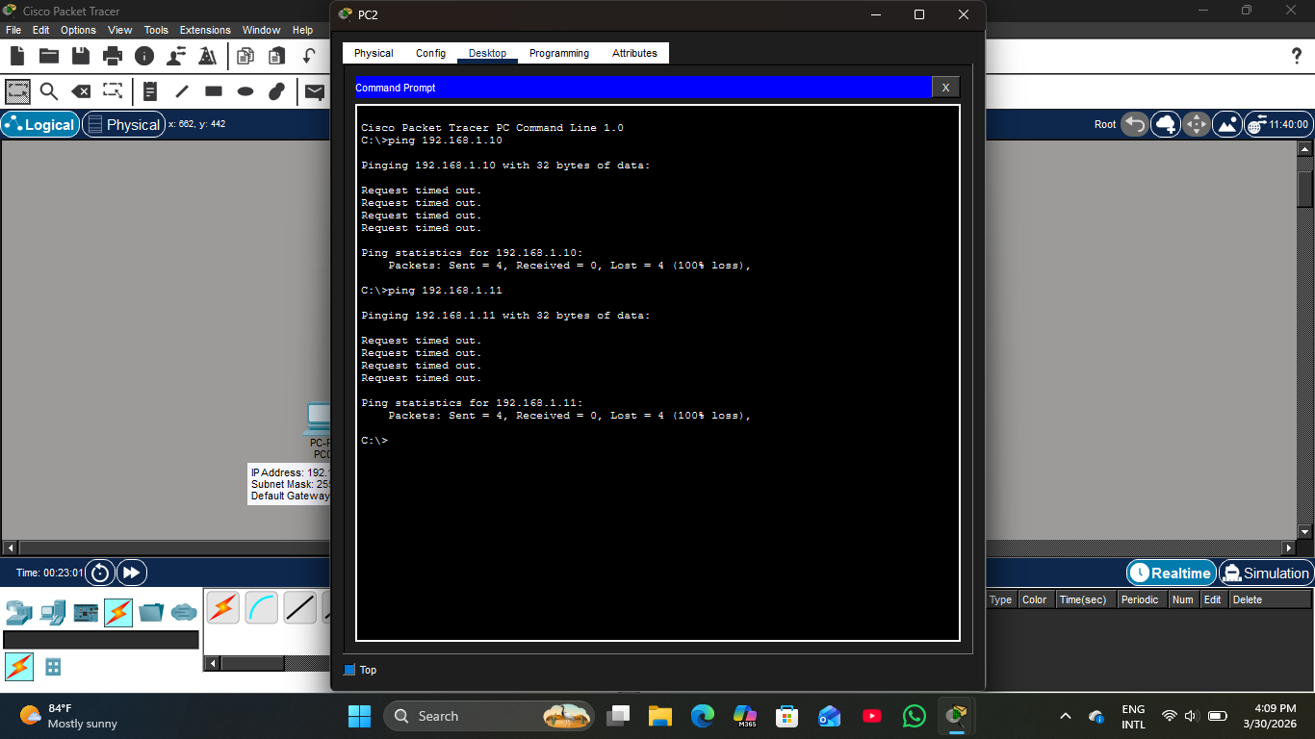

Entering second set of commands in Router CLI
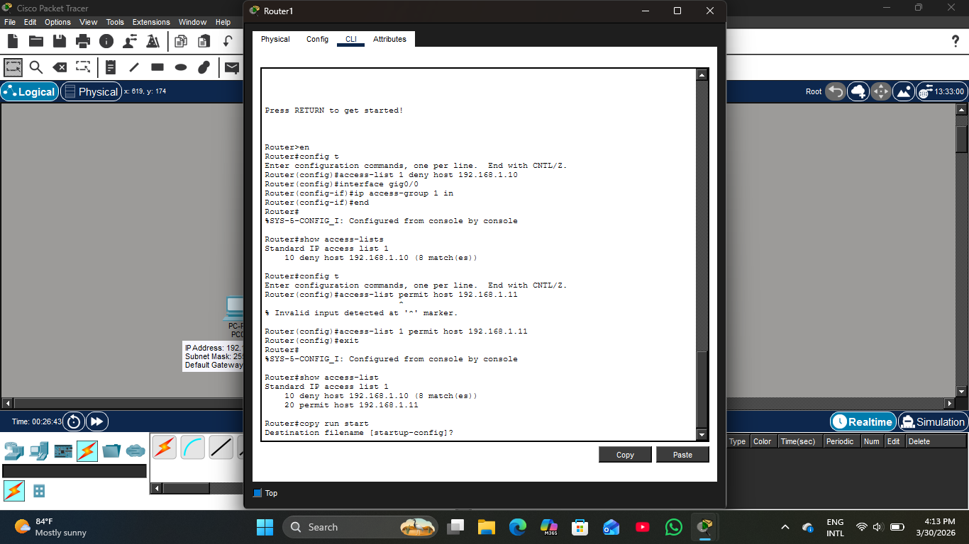

Running Pings in PC0 again
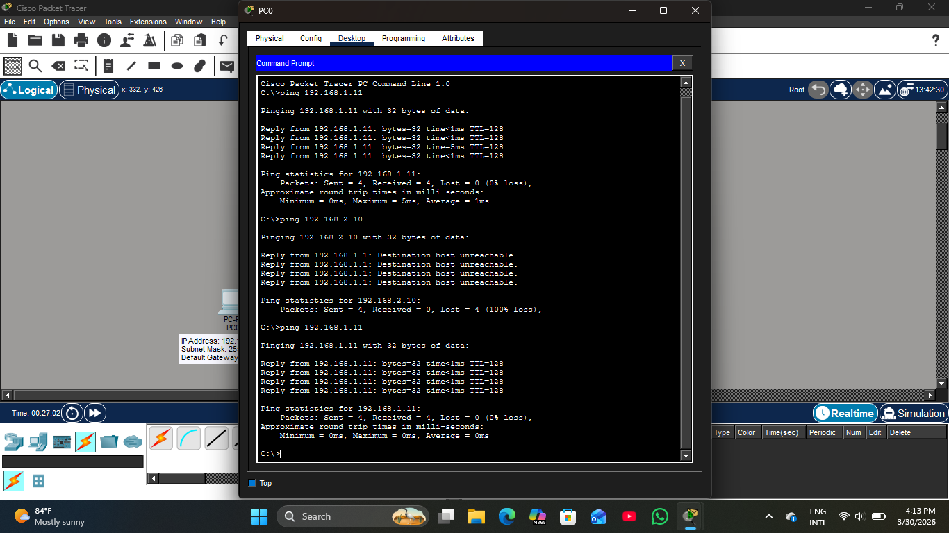

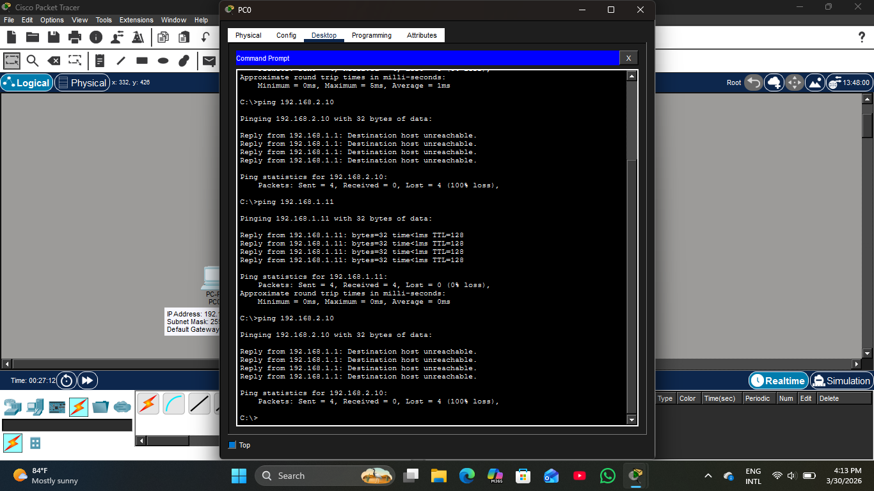

Running Pings in PC2 again
